CS 340 Project Two: Grazioso Salvare Dashboard
Student Name:
Ehab Abdelmeseh

Project Overview
The purpose of this project was to develop a full-stack dashboard application for Grazioso Salvare, an international rescue animal training organization. The dashboard allows users to interact with animal shelter data stored in a MongoDB database and identify dogs suitable for different types of rescue training.
The application was designed to provide an intuitive interface that enables users to filter, visualize, and analyze animal data efficiently. By integrating database functionality with a web-based dashboard, this project demonstrates the application of client/server architecture and database-driven development.

Dashboard Functionality
The completed dashboard includes the following features:
- Interactive Filtering Options
  - Users can filter data by rescue type:
    - Water Rescue
    - Mountain or Wilderness Rescue
    - Disaster or Individual Tracking
    - Reset (default view)
- Interactive Data Table
  - Displays records from the MongoDB database
  - Supports:
    - Sorting
    - Filtering
    - Pagination
  - Updates dynamically based on selected filters
- Data Visualization (Chart)
  - A pie chart displays the distribution of dog breeds
  - Updates automatically based on filtered data
- Geolocation Map
  - Displays the location of selected animals using latitude and longitude
  - Updates when a user selects a row in the data table
- Branding and Identification
  - Includes the Grazioso Salvare logo
  - Displays the developer’s name as a unique identifier

Screenshots of Dashboard Execution
1. Default View (Reset)
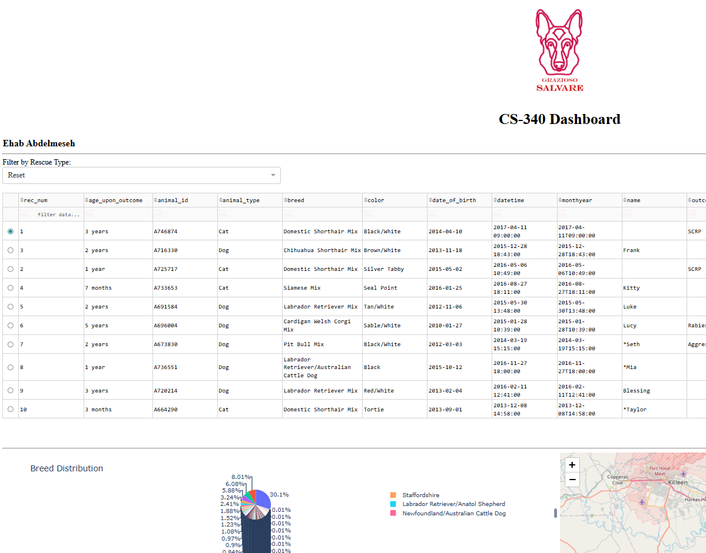2. Water Rescue Filter Applied
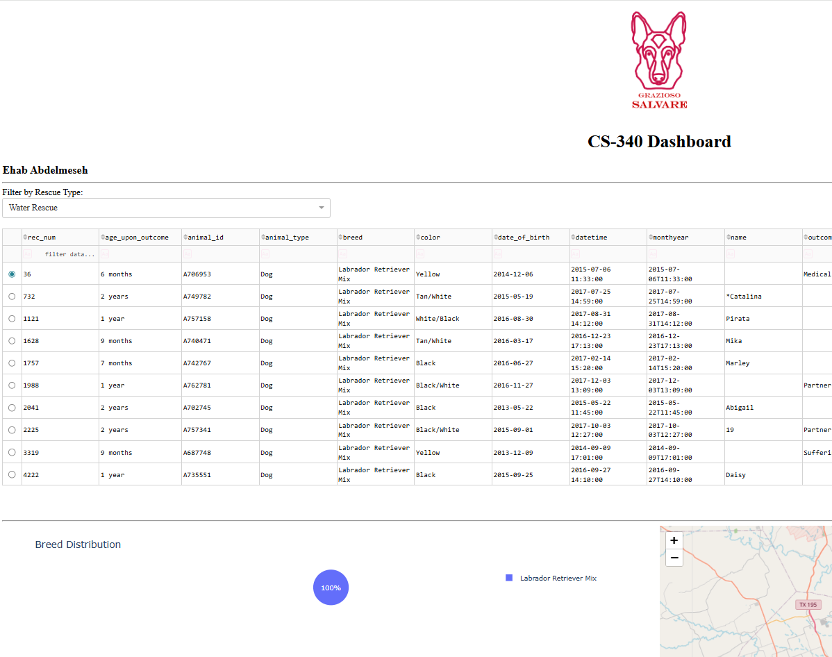
3. Mountain/Wilderness Rescue Filter Applied
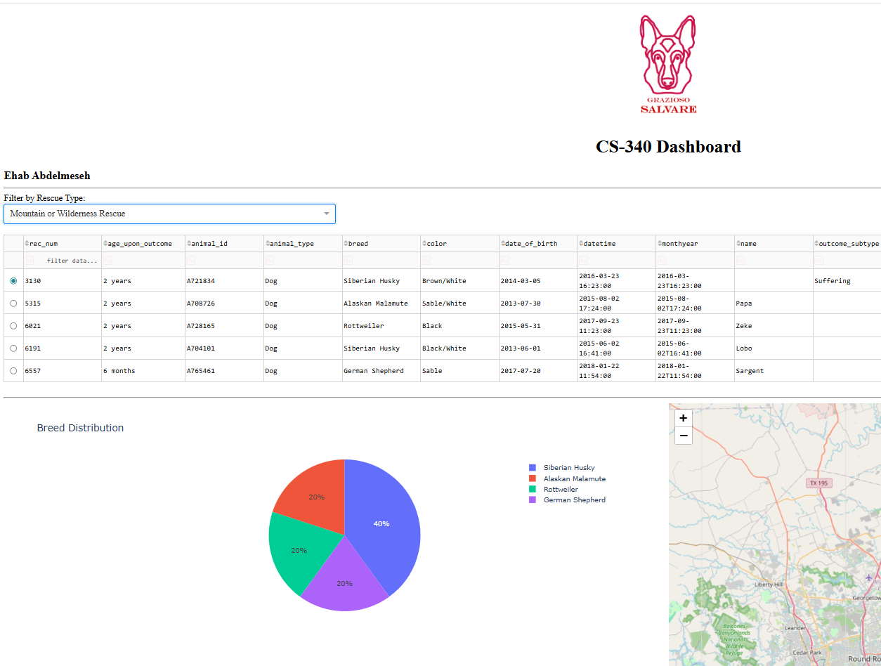4. Disaster/Tracking Filter Applied
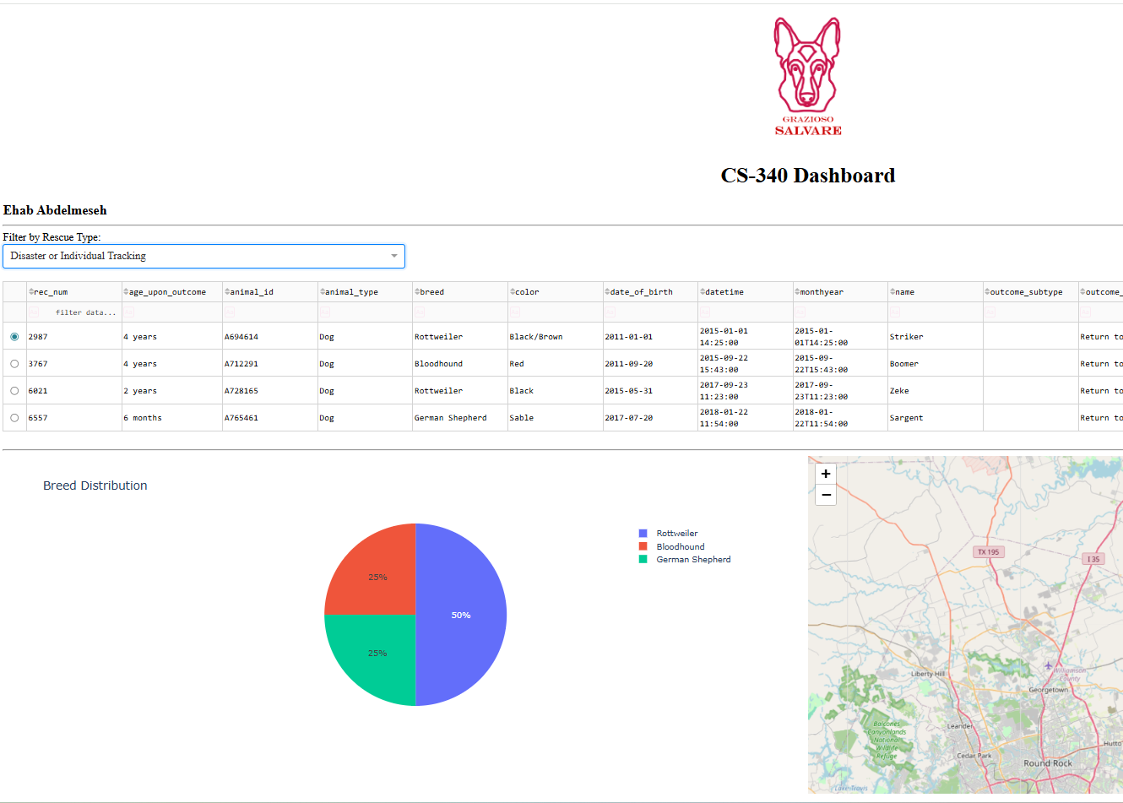

Tools and Technologies Used
MongoDB
MongoDB was used as the database (model component) to store and manage animal shelter data. It is a NoSQL database that stores data in a flexible, JSON-like format, making it ideal for handling semi-structured data such as animal records.
MongoDB was chosen because:
- It integrates easily with Python using libraries like PyMongo
- It supports flexible schema design
- It allows efficient querying for filtering operations
- It handles large datasets effectively

Python
Python was used to develop both the backend logic and the dashboard functionality. A custom CRUD (Create, Read, Update, Delete) module was developed in Project One and reused in this project to interact with MongoDB.
Python was selected because:
- It has strong support for database integration
- It is widely used in data-driven applications
- It simplifies backend logic and data processing

Dash Framework
Dash was used to build the web-based dashboard interface (view and controller components). It allows developers to create interactive web applications entirely in Python without needing HTML, CSS, or JavaScript.
Dash was chosen because:
- It supports interactive components such as dropdowns and tables
- It enables real-time updates through callbacks
- It integrates seamlessly with Plotly for data visualization

Plotly
Plotly was used to generate the pie chart visualization.
It was selected because:
- It produces high-quality interactive charts
- It integrates directly with Dash
- It updates dynamically based on user input

Dash Leaflet
Dash Leaflet was used to create the geolocation map.
It was chosen because:
- It allows easy visualization of geographic data
- It supports markers and interactive popups
- It integrates well with Dash applications

Steps Taken to Complete the Project
- Connected to the MongoDB database using the CRUD Python module
- Retrieved all animal records and displayed them in a Dash data table
- Implemented interactive filtering options using a dropdown menu
- Created MongoDB queries to filter data based on rescue types
- Updated the data table dynamically using Dash callbacks
- Developed a pie chart to visualize breed distribution
- Implemented a geolocation map using latitude and longitude data
- Added branding (logo) and a unique identifier
- Tested the dashboard to ensure all components worked correctly
- Captured screenshots demonstrating functionality

Challenges and Solutions
Challenge 1: MongoDB Data Formatting
The _id field returned from MongoDB caused issues in the data table because it used an unsupported object type.
Solution:
The _id column was removed from the DataFrame before displaying the data.

Challenge 2: Filters Returning No Results
Some filters initially returned no data due to mismatches between breed names in the dataset and the query.
Solution:
Queries were adjusted to match the dataset values accurately, ensuring correct filtering results.

Challenge 3: Callback Errors
Errors such as NoneType is not iterable occurred when callbacks received empty or uninitialized data.
Solution:
Conditional checks were added to ensure callbacks handle empty or missing data safely.

Challenge 4: Layout and Screenshot Space
The dashboard initially displayed inside Jupyter Notebook, limiting space for screenshots.
Solution:
The dashboard was launched in external mode to allow full-screen viewing for clean screenshots.

Conclusion
This project successfully demonstrates the integration of a MongoDB database with a Python-based web dashboard using Dash. The application provides an intuitive and interactive interface for analyzing animal shelter data, enabling users to identify suitable rescue dogs efficiently.
The design follows a client/server model and effectively applies database principles, interactive UI components, and data visualization techniques.

